ChIP-seq analytics, Practical 2
Created by Jun Wang, 2025/2026, CAN7031/131

This practical covers ChIP-seq downstream analysis after peak calling, including peak annotation, comparison between samples and transcription factor (TF) binding analysis. We will use the R package ‘ChIPseeker’ for peak annotation and sample comparison, and use MEME suite for TF binding motif analysis

(1) First open Rstudio, install and load R packages, ‘ChIPseeker’, gene annotation library

Use Bioconductor biocManager to install required R packages

if (!require("BiocManager", quietly = TRUE))
install.packages("BiocManager")
BiocManager::install("ChIPseeker")

if (!require("BiocManager", quietly = TRUE))
install.packages("BiocManager")
BiocManager::install("TxDb.Hsapiens.UCSC.hg19.knownGene")

This installs "TxDb.Hsapiens.UCSC.hg19.knownGene" database in your R. If you sequencing data is analysed using hg38, install "TxDb.Hsapiens.UCSC.hg38.knownGene"

You may get an error message saying

Warning message:
package(s) not installed when version(s) same as or greater than current; use
`force = TRUE` to re-install: 'TxDb.Hsapiens.UCSC.hg19.knownGene'

You either have already installed this package, or just re-install it including `force = TRUE` into the installation command

For example, BiocManager::install("TxDb.Hsapiens.UCSC.hg19.knownGene", force = TRUE)

Now load “ChIPseeker” and “TxDb.Hsapiens.UCSC.hg19.knownGene”

> library(ChIPseeker)
> library(TxDb.Hsapiens.UCSC.hg19.knownGene)

You should load these two packages successfully. Then you are ready to run ChIPseeker.

(2) Download three file from QMplus CAN7031/131 module page under ChIP-seq tab, namely (three bed files)
GSM1574235_H3K27ac.CAPAN1_vs_INPUT.CAPAN1_peaks_hg19_chr12.bed
GSM1574242_H3K4me1.CAPAN1_vs_INPUT.CAPAN1_peaks_hg19_chr12.bed
GSM1574256_H3K4me3.CAPAN1_vs_INPUT.CAPAN1_peaks_hg19_chr12.bed

Use R to read the peak files and ChIPseeker to load peak files. Here we only use peak calls from hg19 chromosome 12 for this practical to save time.

In Rstudio, set you working directory

> setwd(“your_working_directory”)

e.g., setwd("/Users/hfw552/Downloads/ChIP_seq_files")

> files <- list("GSM1574235_H3K27ac.CAPAN1_vs_INPUT.CAPAN1_peaks_hg19_chr12.bed", "GSM1574242_H3K4me1.CAPAN1_vs_INPUT.CAPAN1_peaks_hg19_chr12.bed", "GSM1574256_H3K4me3.CAPAN1_vs_INPUT.CAPAN1_peaks_hg19_chr12.bed")

## common error here is using “. This is the wrong double quote in R. You should use ". You can just copy this " in R to use

> files
[[1]]
[1] "GSM1574235_H3K27ac.CAPAN1_vs_INPUT.CAPAN1_peaks_hg19_chr12.bed"

[[2]]
[1] "GSM1574242_H3K4me1.CAPAN1_vs_INPUT.CAPAN1_peaks_hg19_chr12.bed"

[[3]]
[1] "GSM1574256_H3K4me3.CAPAN1_vs_INPUT.CAPAN1_peaks_hg19_chr12.bed"

> files[[3]]
[1] "GSM1574256_H3K4me3.CAPAN1_vs_INPUT.CAPAN1_peaks_hg19_chr12.bed"

> peak <- readPeakFile(files[[3]], header=F)
> peak
GRanges object with 1507 ranges and 2 metadata columns:
seqnames ranges strand | V4 V5
<Rle> <IRanges> <Rle> | <character> <numeric>
[1] chr12 253452-254110 * | MACS_peak_5799 51.82
[2] chr12 297877-298674 * | MACS_peak_5800 100.90
[3] chr12 495461-499966 * | MACS_peak_5801 3100.00
[4] chr12 509687-512362 * | MACS_peak_5802 3100.00
[5] chr12 568181-570851 * | MACS_peak_5803 3100.00
... ... ... ... . ... ...
[1503] chr12 133756569-133762618 * | MACS_peak_7301 3100.00
[1504] chr12 133762727-133765402 * | MACS_peak_7302 227.64
[1505] chr12 133765929-133772514 * | MACS_peak_7303 1174.17
[1506] chr12 133777056-133784094 * | MACS_peak_7304 3100.00
[1507] chr12 133786907-133787946 * | MACS_peak_7305 63.83
-------
seqinfo: 1 sequence from an unspecified genome; no seqlengths

### now you have “peak” as the ChIP peaks of H3K4me3 CAPAN1_vs_INPUT data from chromosome 12, in total of 1507 peaks

(3) Create a chromosome plot to display the ChIP peaks over chromosomes

> covplot(peak, weightCol="V5", chrs="chr12")

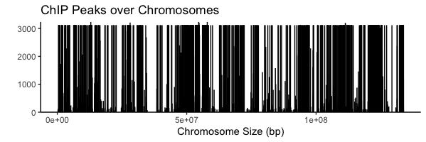

(4) Profile of ChIP peaks binding to transcription starting site (TSS) regions

> txdb19 <- TxDb.Hsapiens.UCSC.hg19.knownGene

> library(clusterProfiler)

## install clusterProfiler package as below if you don’t have it in your computer

if (!require("BiocManager", quietly = TRUE))
install.packages("BiocManager")
BiocManager::install("clusterProfiler")

## first prepare the TSS regions
## expand the region to upstream 3000bp and downstream 3000bp

> promoter <- getPromoters(TxDb=txdb19, upstream=3000, downstream=3000)
> tagMatrix <- getTagMatrix(peak, windows=promoter)
###>> preparing start_site regions by ... 2022-10-14 10:34:15
###>> preparing tag matrix... 2022-10-14 10:34:15

##Heatmap of ChIP binding to TSS regions
> tagHeatmap(tagMatrix, xlim=c(-3000, 3000), color="red")
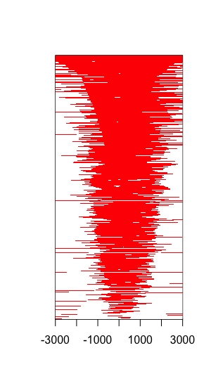
Or just try

> tagHeatmap(tagMatrix)

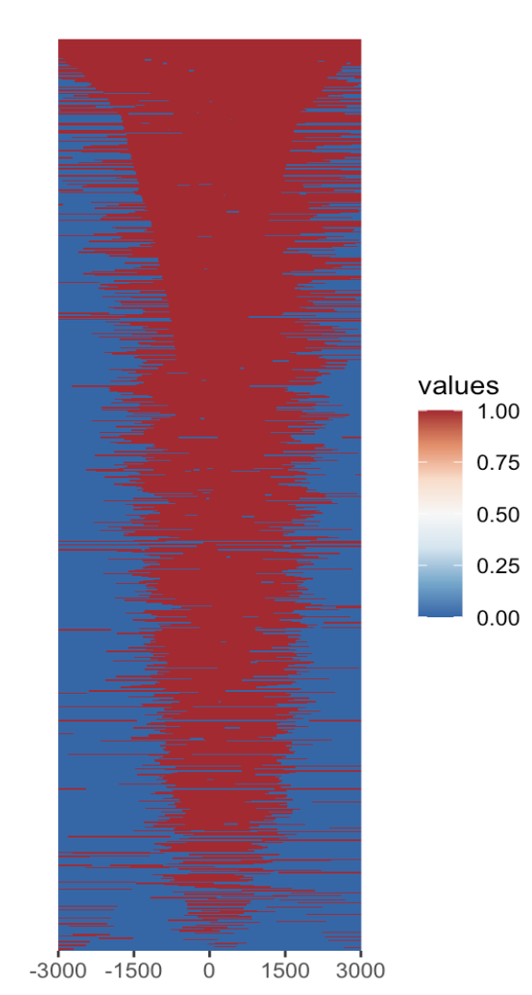

##Average Profile of ChIP peaks binding to TSS region
> plotAvgProf(tagMatrix, xlim=c(-3000, 3000),
xlab="Genomic Region (5'->3')", ylab = "Read Count Frequency")
###>> plotting figure... 2022-10-14 10:35:37
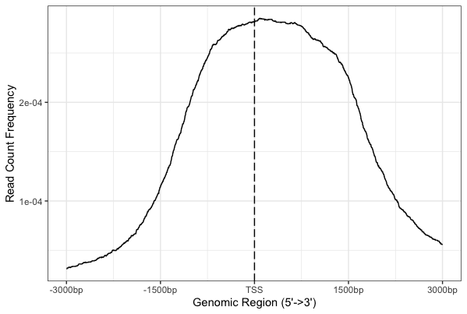

##Confidence interval estimated by bootstrap method
> plotAvgProf(tagMatrix, xlim=c(-3000, 3000), conf = 0.95, resample = 1000)
###>> plotting figure... 2022-10-13 17:03:45
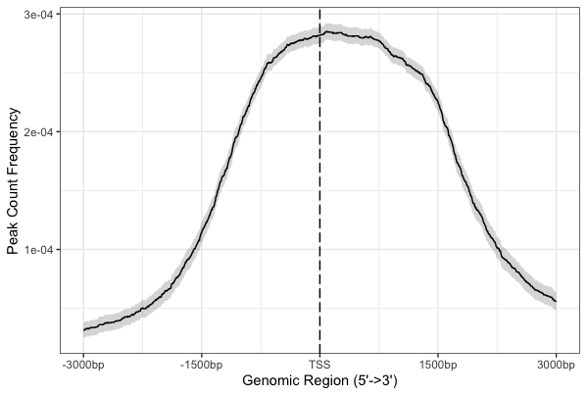

## be mindful if you do this for the whole chromosome, as this resampling to calculate 95% confidence interval will take lots of your computing resources and time.

(5) Profile of ChIP peaks binding to body regions

##Here uses `plotPeakProf2` to do all things in one step.
##Binning method for profile of ChIP peaks
## the ignore_strand is FALSE in default. We put here to emphasize that.

> plotPeakProf2(peak = peak, upstream = rel(0.2), downstream = rel(0.2),
conf = 0.95, by = "gene", type = "body", nbin = 800,
TxDb = txdb19, weightCol = "V5",ignore_strand = F)
##>> binning method is used…2022-10-14 10:48:08
##>> preparing body regions by gene... 2022-10-14 10:48:08
##>> preparing tag matrix by binning... 2022-10-14 10:48:08
##>> preparing matrix with extension from (TSS-20%)~(TTS+20%)... 2022-10-14 10:48:08
##>> 12 peaks(1.423488%), having lengths smaller than 800bp, are filtered... 2022-10-14 10:48:10

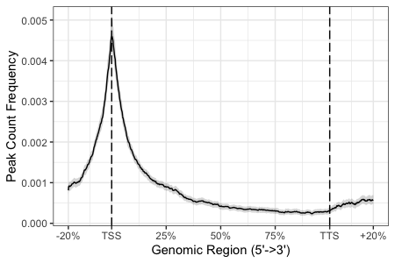

## we can also use getBioRegion(), getTagMatrix() and plotPeakProf() to plot in three steps.

> genebody <- getBioRegion(TxDb = txdb19, by = "gene", type = "body")
> matrix_no_flankextension <- getTagMatrix(peak,windows = genebody, nbin = 800)
##>> binning method is used...2022-10-14 10:49:54
##>> preparing body regions by … 2022-10-14 10:49:54
##>> preparing tag matrix by binning... 2022-10-14 10:49:54
##>> preparing matrix for body region with no flank extension... 2022-10-14 10:49:54
##>> 12 peaks(1.494396%), having lengths smaller than 800bp, are filtered... 2022-10-14 10:49:54

> plotPeakProf(matrix_no_flankextension,conf = 0.95)
##>> Running bootstrapping for tag matrix... 2022-10-14 10:50:12

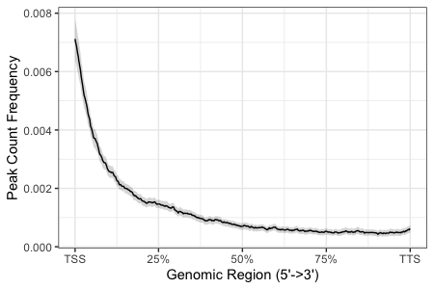

#### you can also use getTagMatrix() and plotPeakProf() to plot in two steps

> matrix_actual_extension <- getTagMatrix(peak,windows = genebody, nbin = 800, upstream = 1000,downstream = 1000)
##>> binning method is used...2022-10-14 10:51:39
##>> preparing body regions by ... 2022-10-14 10:51:39
##>> preparing tag matrix by binning... 2022-10-14 10:51:39
##>> preparing matrix with flank extension from (TSS-1000bp)~(TTS+1000bp)... 2022-10-14 10:51:39
##>> 15 peaks(1.838235%), having lengths smaller than 800bp, are filtered... 2022-10-14 10:51:39

> plotPeakProf(matrix_actual_extension,conf = 0.95)
##>> Running bootstrapping for tag matrix... 2022-10-14 10:51:55

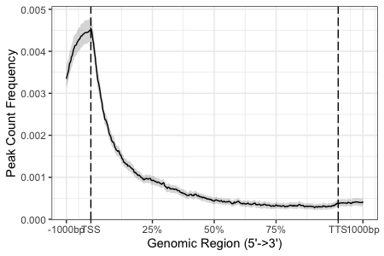

## see the manual to plot against other regions

(6) Peak annotation

## Since some annotation may overlap, ChIPseeker adopted the following priority in genomic annotation: Promoter, 5’ UTR, 3’ UTR, Exon, Intron, Downstream, Intergenic

## install Bioconductor R package ("org.Hs.eg.db")

if (!require("BiocManager", quietly = TRUE))
install.packages("BiocManager")
BiocManager::install("org.Hs.eg.db")

> library(org.Hs.eg.db)
> peakAnno <- annotatePeak(peak, tssRegion=c(-3000, 3000),
TxDb=txdb19, annoDb="org.Hs.eg.db")
##>> preparing features information... 2022-10-14 10:54:10
##>> identifying nearest features... 2022-10-14 10:54:11
##>> calculating distance from peak to TSS... 2022-10-14 10:54:12
##>> assigning genomic annotation... 2022-10-14 10:54:12
##>> assigning chromosome lengths 2022-10-14 10:54:31
##>> done... 2022-10-14 10:54:31

> plotAnnoPie(peakAnno)

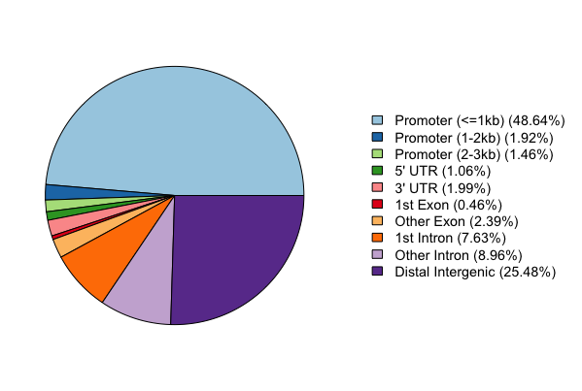
## Note that we use H3K4me3 peaks to annotate in the example, and H3K4me3 marks the active promoter regions, this confirms that H3K4me3 marked regions largely reside with promoter regions in this annotation.
## This pie chart is very different from the one in the lecture slides where H3K27ac peaks were used, which marks active enhancer regions.

> plotAnnoBar(peakAnno)

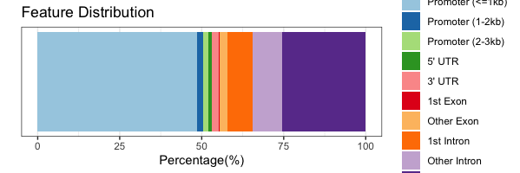

## plotDistToTSS to calculate the percentage of binding sites upstream and downstream from the TSS of the nearest genes, and visualize the distribution.

> plotDistToTSS(peakAnno,
title="Distribution of transcription factor-binding loci\nrelative to TSS")

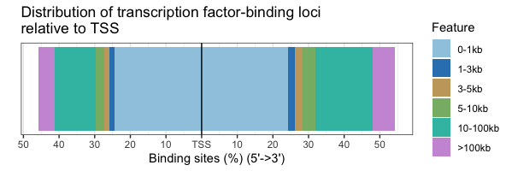

## again you can see H3K4me3 peaks were largely around promoter regions

(7) Compare multiple peaks using ChIPseeker

Now we use the three peak files "GSM1574235_H3K27ac.CAPAN1_vs_INPUT.CAPAN1_peaks_hg19_chr12.bed", "GSM1574242_H3K4me1.CAPAN1_vs_INPUT.CAPAN1_peaks_hg19_chr12.bed", "GSM1574256_H3K4me3.CAPAN1_vs_INPUT.CAPAN1_peaks_hg19_chr12.bed", and compare peaks between them

Note that, enhancers are marked by H3K4me1, and promoters are marked by H3K4me3, and H3K27ac marks open chromatin and enchancers

> files
[[1]]
[1] "GSM1574235_H3K27ac.CAPAN1_vs_INPUT.CAPAN1_peaks_hg19_chr12.bed"

[[2]]
[1] "GSM1574242_H3K4me1.CAPAN1_vs_INPUT.CAPAN1_peaks_hg19_chr12.bed"

[[3]]
[1] "GSM1574256_H3K4me3.CAPAN1_vs_INPUT.CAPAN1_peaks_hg19_chr12.bed"

> names(files) <- c("H3K27ac", "H3K4me1", "H3K4me3")

> library(TxDb.Hsapiens.UCSC.hg19.knownGene)
> txdb <- TxDb.Hsapiens.UCSC.hg19.knownGene
> library(clusterProfiler)
> promoter <- getPromoters(TxDb=txdb, upstream=3000, downstream=3000)
> tagMatrixList <- lapply(files, getTagMatrix, windows=promoter)
##>> preparing start_site regions by ... 2022-10-14 11:12:19
##>> preparing tag matrix... 2022-10-14 11:12:19
##>> preparing start_site regions by ... 2022-10-14 11:12:21
##>> preparing tag matrix... 2022-10-14 11:12:21
##>> preparing start_site regions by ... 2022-10-14 11:12:21
##>> preparing tag matrix... 2022-10-14 11:12:21

## we will compare the peaks among the three files in relation to promoters

## average profile of the 3 bed files against promoters
> plotAvgProf(tagMatrixList, xlim=c(-3000, 3000))
##>> plotting figure... 2022-10-14 11:18:40
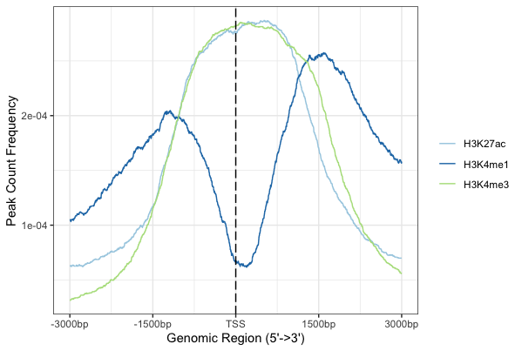

> plotAvgProf(tagMatrixList, xlim=c(-3000, 3000),
conf=0.95,resample=500, facet="row")
##>> plotting figure... 2022-10-14 11:20:43
##>> Running bootstrapping for tag matrix... 2022-10-14 11:20:57
##>> Running bootstrapping for tag matrix... 2022-10-14 11:21:14
##>> Running bootstrapping for tag matrix... 2022-10-14 11:21:31

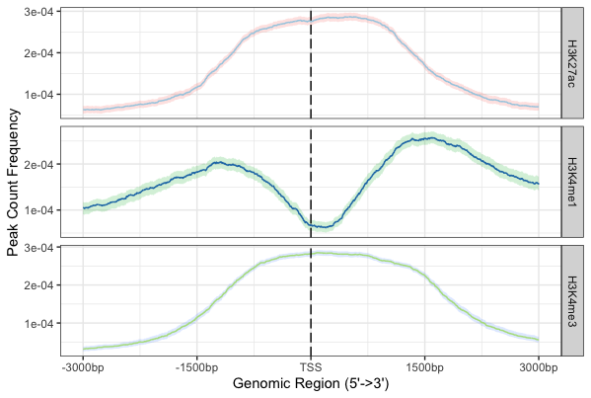

### peak heatmap across samples

## you can clear all previous plot using the following command
## > dev.off()

> tagHeatmap(tagMatrixList, xlim=c(-3000, 3000), color=NULL)

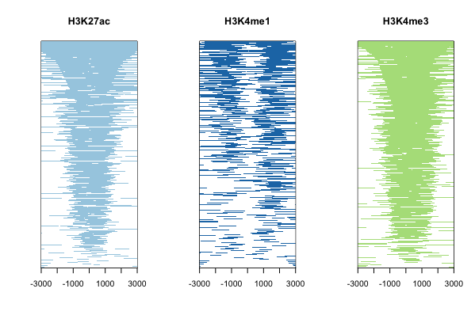
Or just try

> tagHeatmap(tagMatrixList)

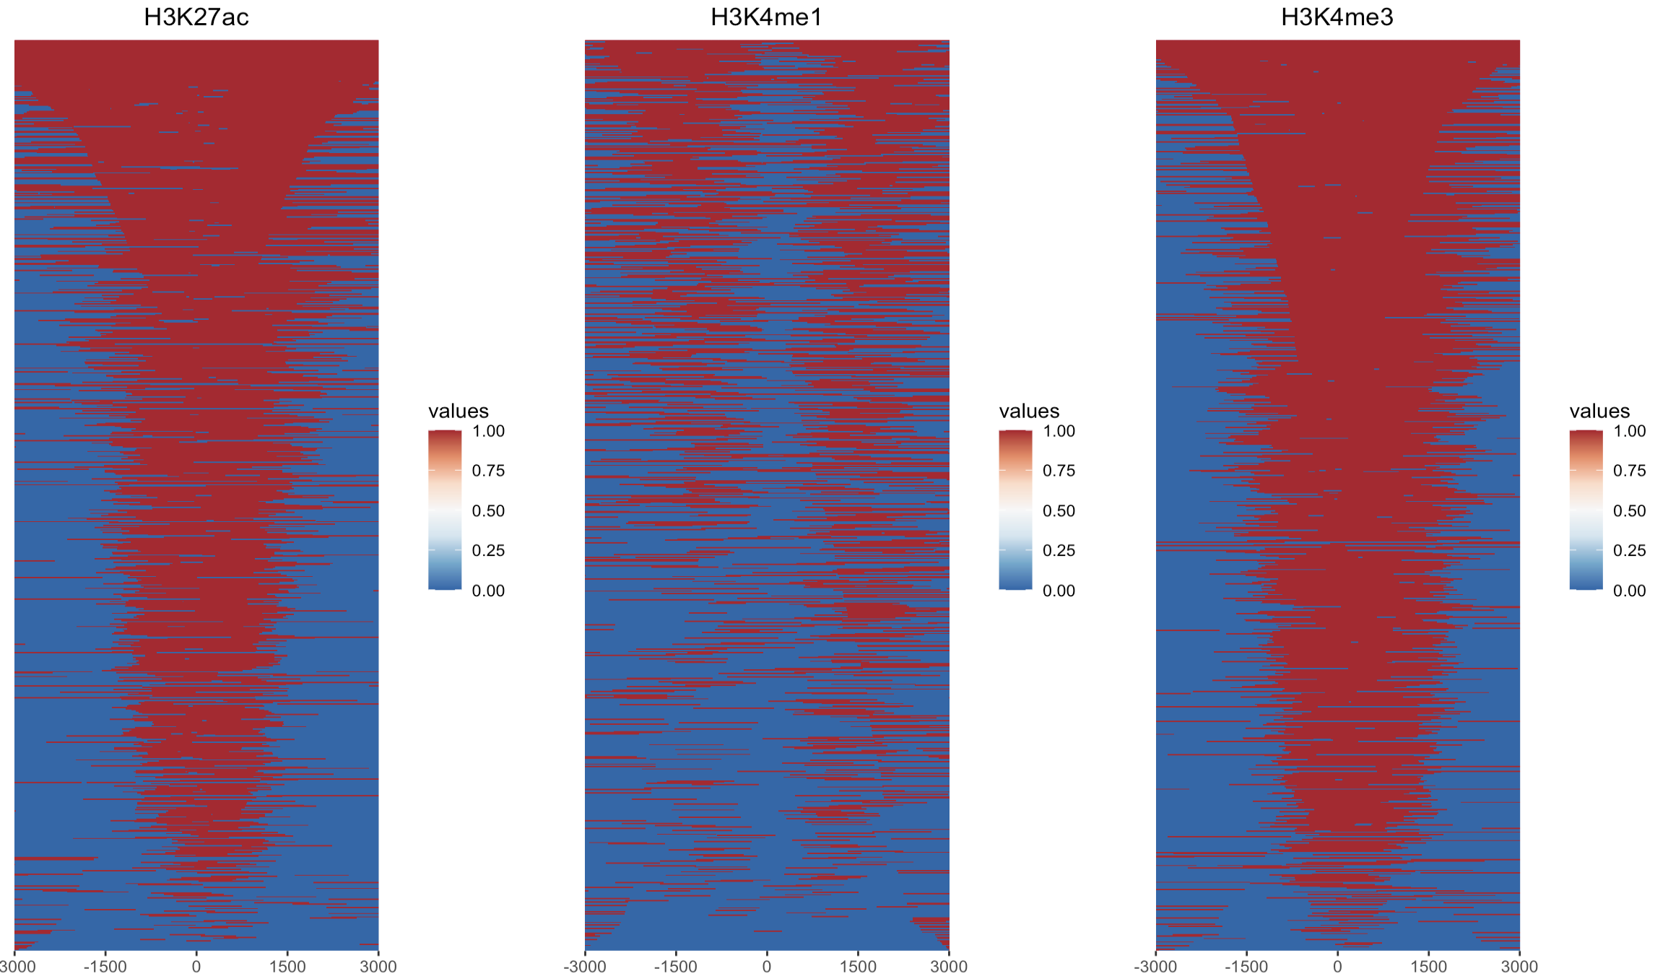

### Profile of the three ChIP peak files binding to body region
> plotPeakProf2(files, upstream = rel(0.2), downstream = rel(0.2),
conf = 0.95, by = "gene", type = "body",
TxDb = txdb, facet = "row", nbin = 800)

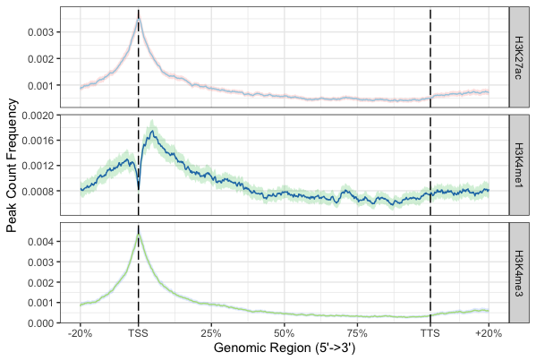

### ChIP peak annotation comparison

> peakAnnoList <- lapply(files, annotatePeak, TxDb=txdb,
tssRegion=c(-3000, 3000), verbose=FALSE)

> ## use plotAnnoBar to comparing their genomic annotation.
> plotAnnoBar(peakAnnoList)

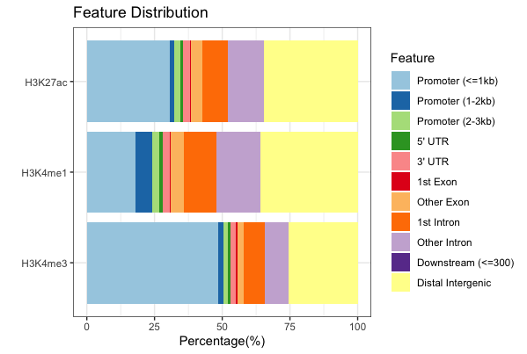

## plotDistToTSS to compare distance to TSS profiles among ChIPseq data.
> plotDistToTSS(peakAnnoList)

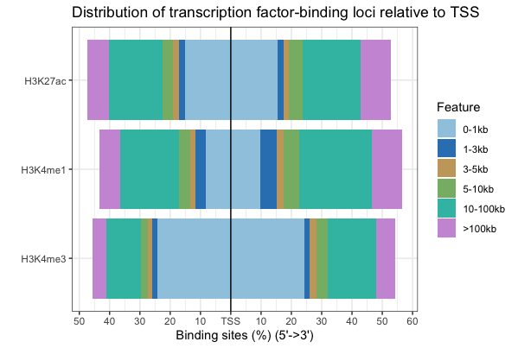

(8) Overlap of peaks and annotated genes

## compared annotated genes across the 3 ChIP-seq peak files
> genes= lapply(peakAnnoList, function(i) as.data.frame(i)$geneId)
> vennplot(genes)

## it is likely your plot looks very thin, so you can clear all previous plots and then re-plot

> dev.off()
> vennplot(genes)

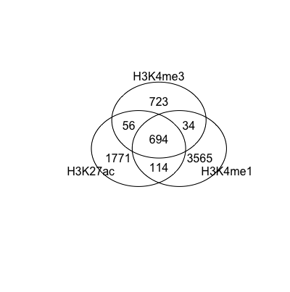

### Finally, we can also perform peak overlap enrichment analysis between these three peak files in the practical.

## Shuffle genome coordination
> p <- GRanges(seqnames="chr12",
ranges=IRanges(start=c(1, 100), end=c(50, 130)))
> shuffle(p, TxDb=txdb)
> enrichPeakOverlap(queryPeak = files[[3]], targetPeak = unlist(files[1:2]), TxDb = txdb, pAdjustMethod = "BH", nShuffle = 50, chainFile = NULL, verbose = FALSE)

## this command compares H3K4me3 peaks against H3K27ac and H3K4me1 peaks, and determine if there is a significant overlap between gene annotation

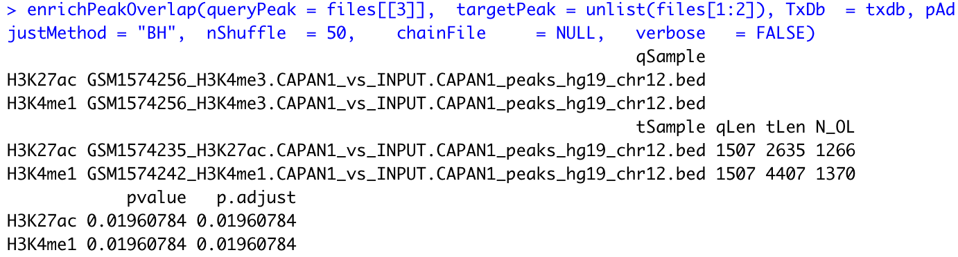

There seems to be a significant overlap of gene annotation between the three gene annotation.

(9) Finally, let’s do some practise using MEME suite for TF binding analysis

As this is a very computational intense analysis, let’s randomly select 10 peaks from the H3K4me3 peaks and perform the motif discovery and enrichment analysis for this practical.

> peaks_H3K4me3 <- read.delim("GSM1574256_H3K4me3.CAPAN1_vs_INPUT.CAPAN1_peaks_hg19_chr12.bed", header=F)

## randomly select 10 peaks from the file
> set.seed(12345) # Set seed for reproducibility

## Sample rows of data with Base R
> data_s1 <- peaks_H3K4me3[sample(1:nrow(peaks_H3K4me3), 10), ]

## Print sampled data
> data_s1

## write this into a new BED file, ready for the analysis using MEME suite
> write.table(data_s1, file="data_s1_H3K4me3.bed", quote=F, sep="\t", row.names=F, col.names = F)

(9.1) Now, we are going to first use MEME suite to perform TF motif discovery

MEME discovers novel, ungapped motifs (recurring, fixed-length patterns) in the query sequences

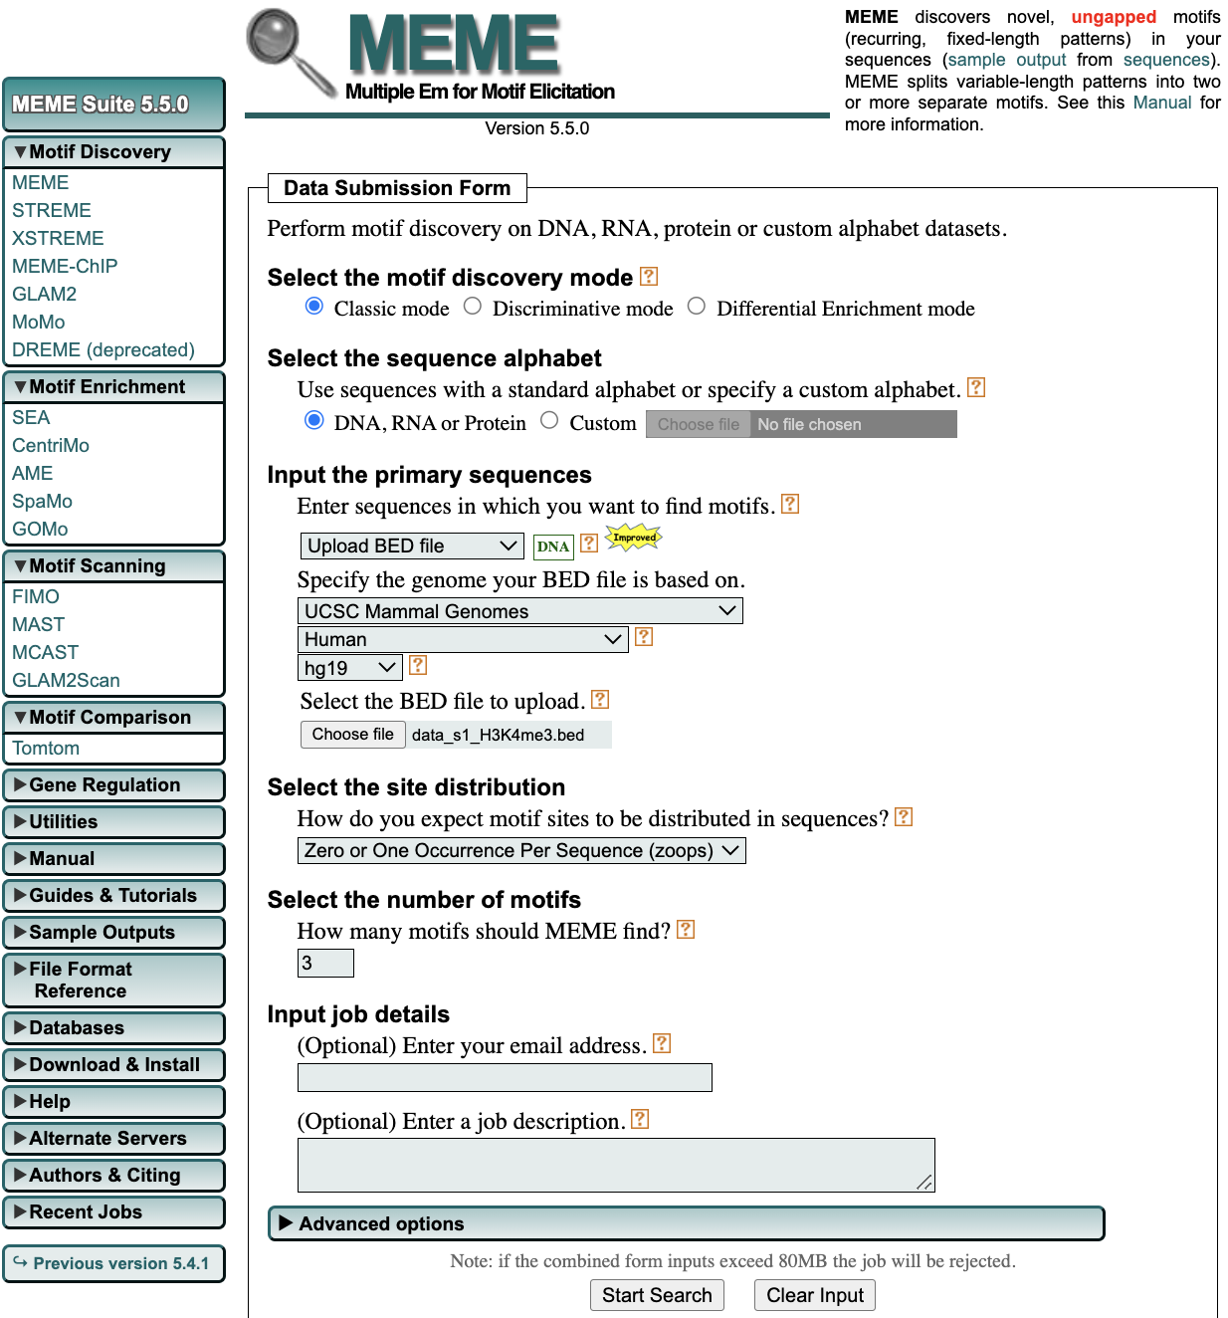
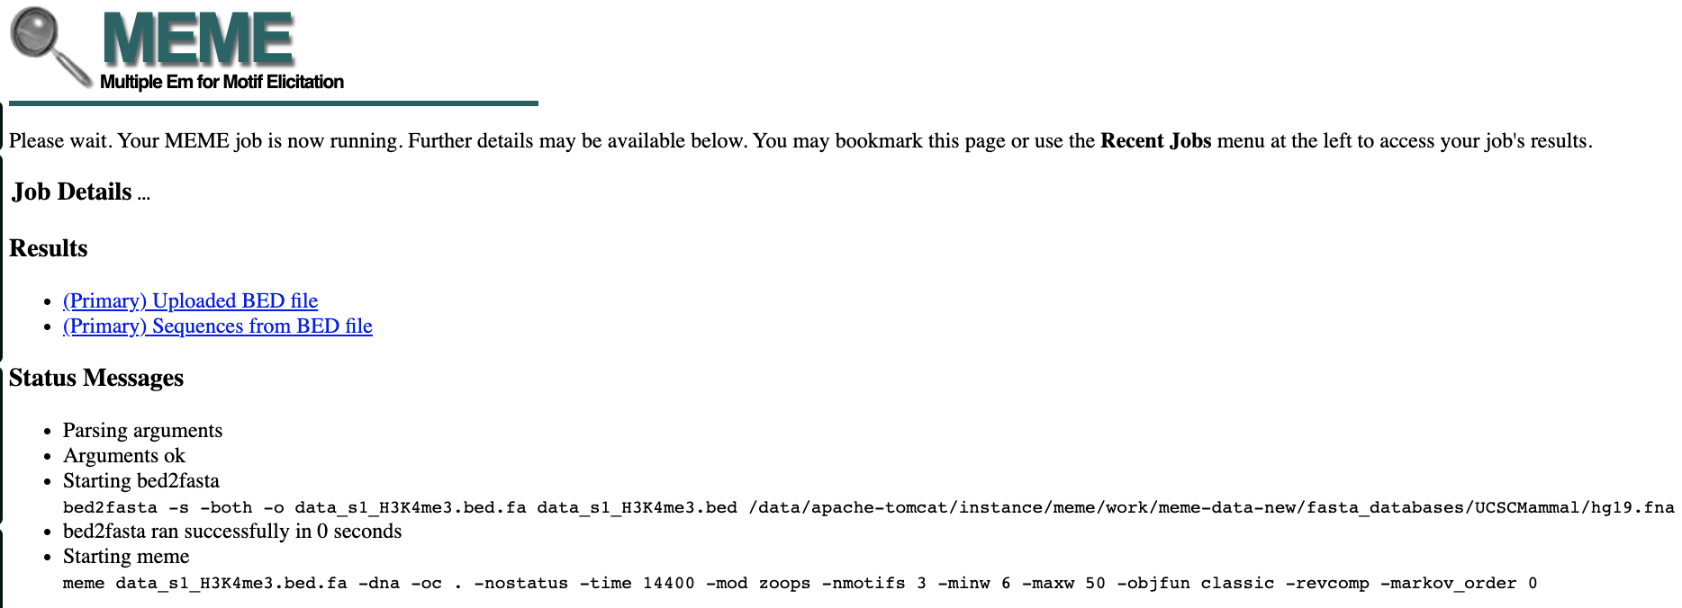

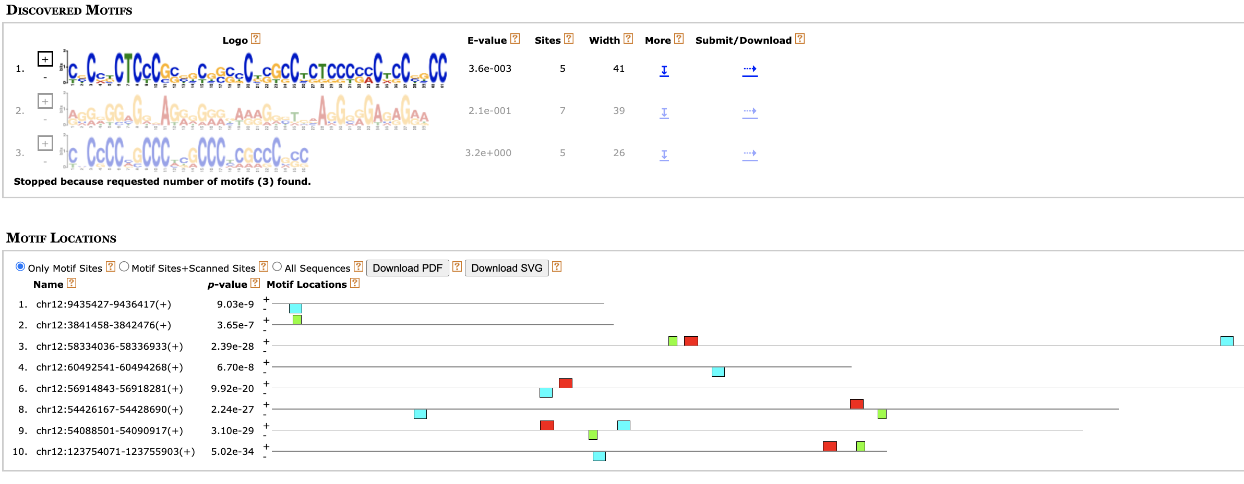

(9.2) use STREME to perform discriminative motif discovery in sequence datasets.
STREME discovers ungapped motifs (recurring, fixed-length patterns) that are enriched in your sequences or relatively enriched in them compared to your control sequences.

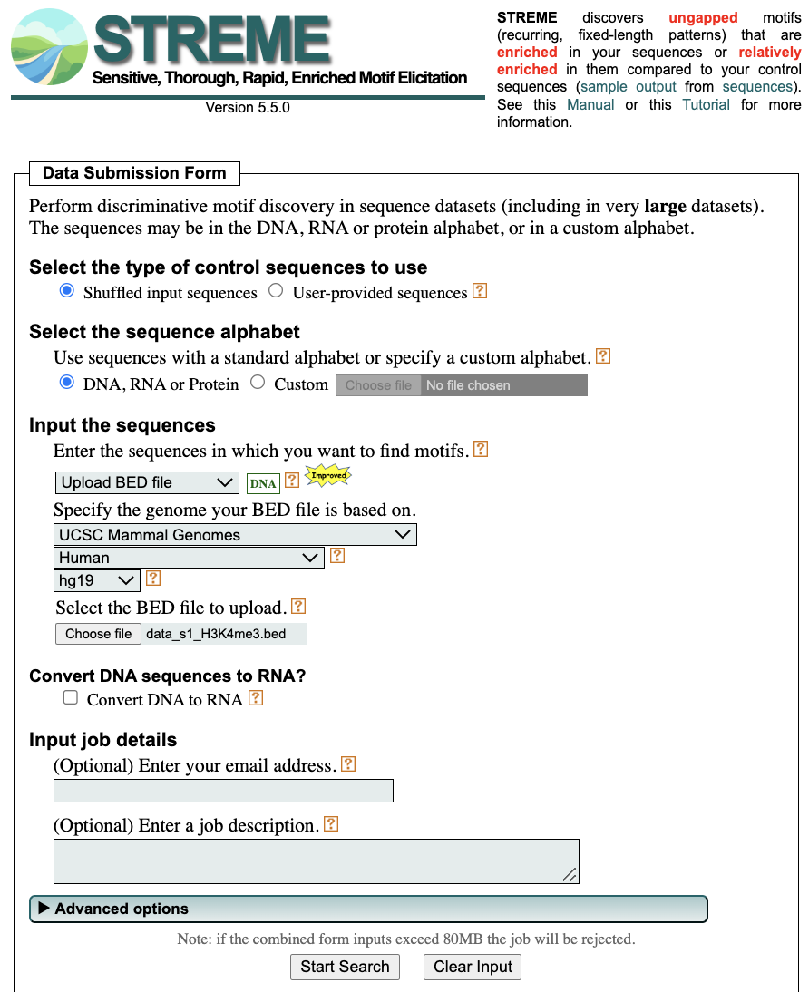

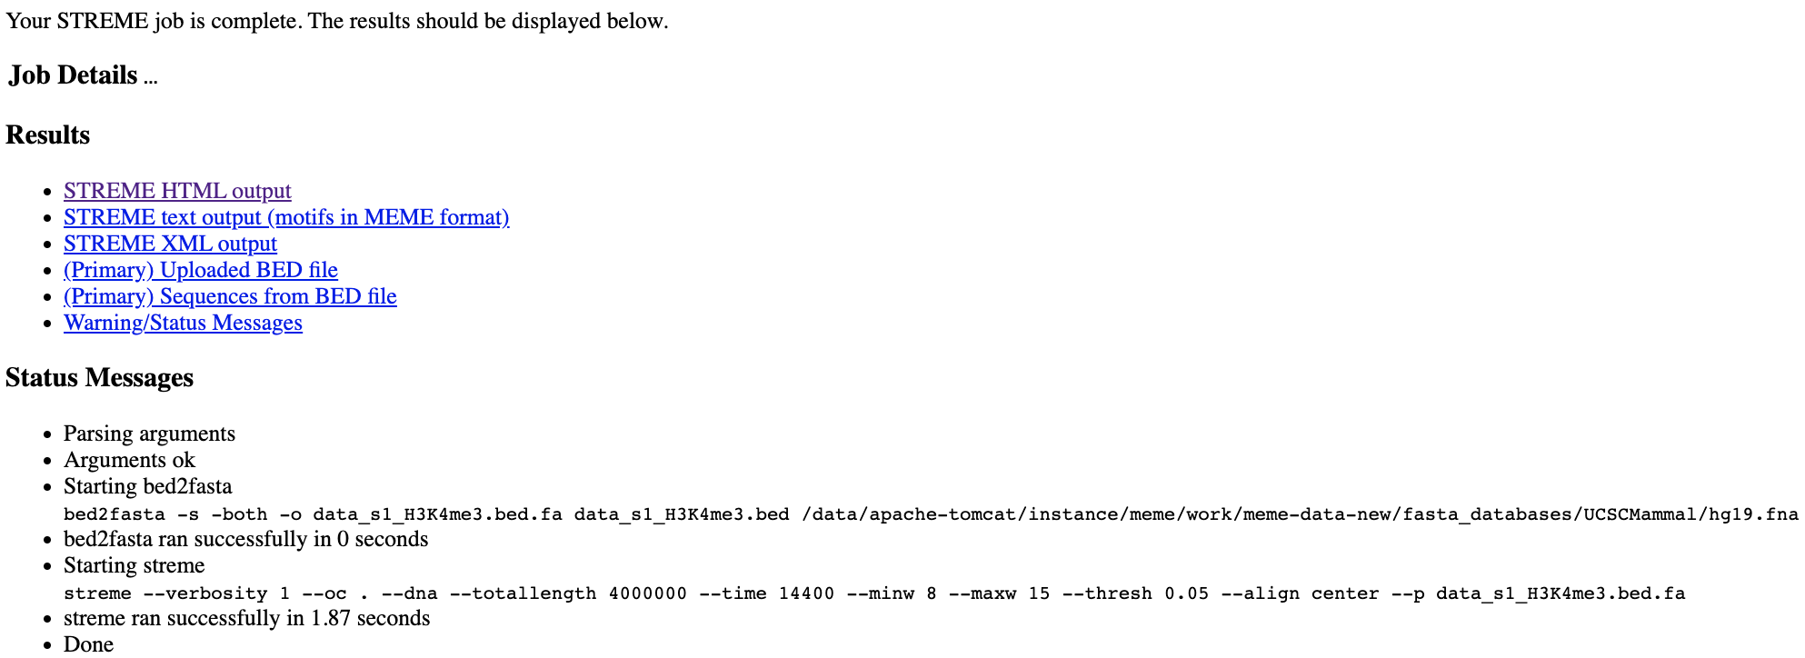

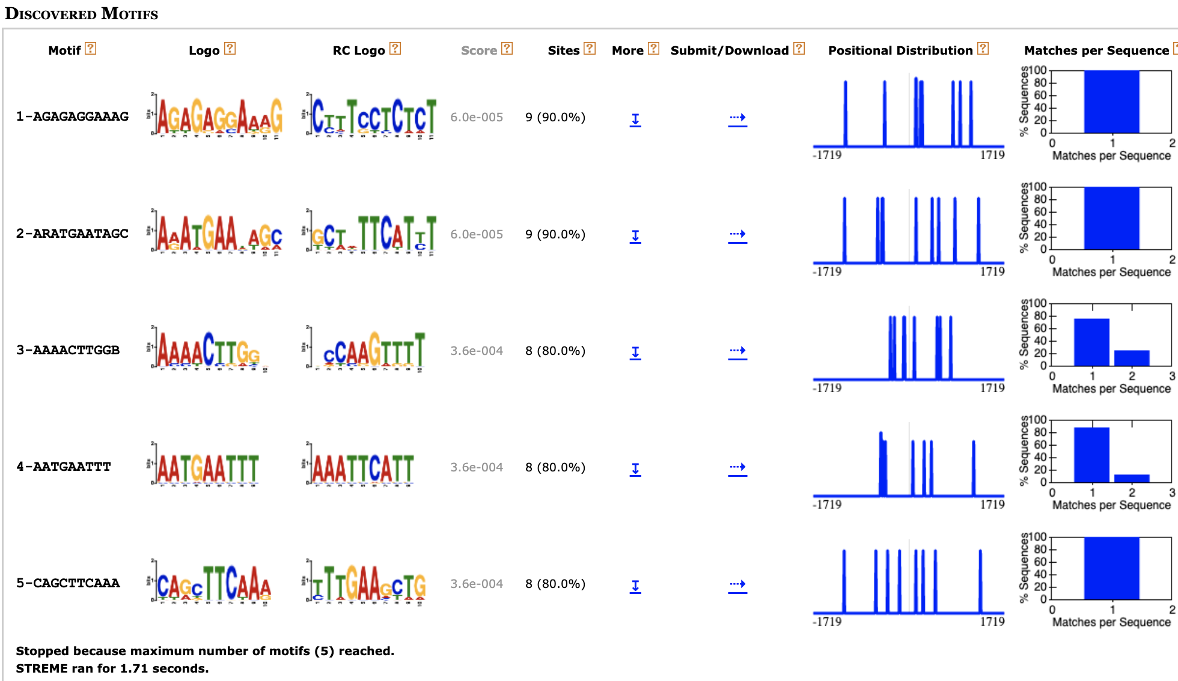
(9.3) use SEA to Perform motif enrichment analysis in sequence datasets.
SEA identifies known or user-provided motifs that are relatively enriched in your sequences compared with shuffled sequences or your control sequences
